- INTRODUCTION
Iganga School of Nursing and Midwifery is a private Nursing School registered by the Registrar of Companies as a Limited Liability Company. The school is also registered with the Ministry of Education & Sports (MOES) and Uganda Nurses and Midwives Council (UNMC).

- VISION, MISSION, STRATEGIC OBJECTIVES AND CORE VALUES

2.1 VISION:
“To have a healthy and disease free community”
2.2 MISSION:
“To produce world class and competitive health workers through the use of modern teaching methods, technology and research”
2.3 STRATEGIC OBJECTIVES:
- Build the Institutional capacity of the school to train quality nurses and midwives
- Enhance resource mobilization, utilization and management for sustainable development of the school
- Develop strategic partnerships and networks at local, national and international levels to enhance the learning/teaching environment
- Promote the participation of all stakeholders in the affairs of the school
2.4 MOTTO:
“Chosen to serve”
Based on a disciplined mind for a health action.

2.5 CORE VALUES
We are operating under the guiding principles of:-
- Good governance
- Transparency and Accountability
- Professionalism
- Teamwork
- Partnerships
- Non Partisan, non-ethnicity, non-religious base

- GOVERNANCE OF THE SCHOOL
3.1. Board of Directors
 | BOARD OF DIRECTORS
1 | Mr. Baliddawa David Byawaka
2 | Dr. Banonya Stephen
3 | Mrs. Mercy Byawaka

The school is owned by three (3) founding members who also constitute the Board of Directors. The Board performs the following functions;-
- Offer strategic direction to the school
- Mobilize resources for academic and development activities
- Ensure that there is a proper teaching and learning environment
- Recruitment, training and retention of
appropriate human resource
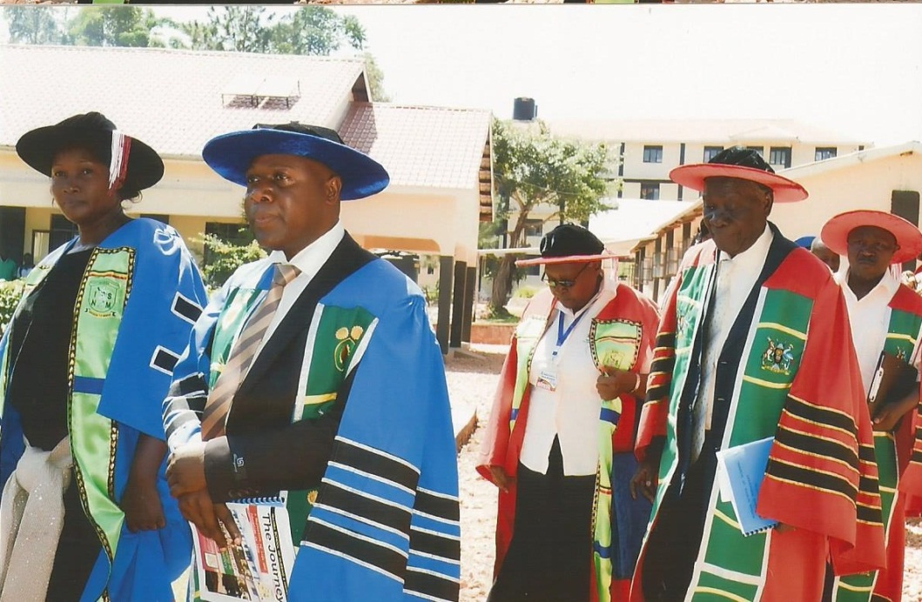

Member Board
of Directors

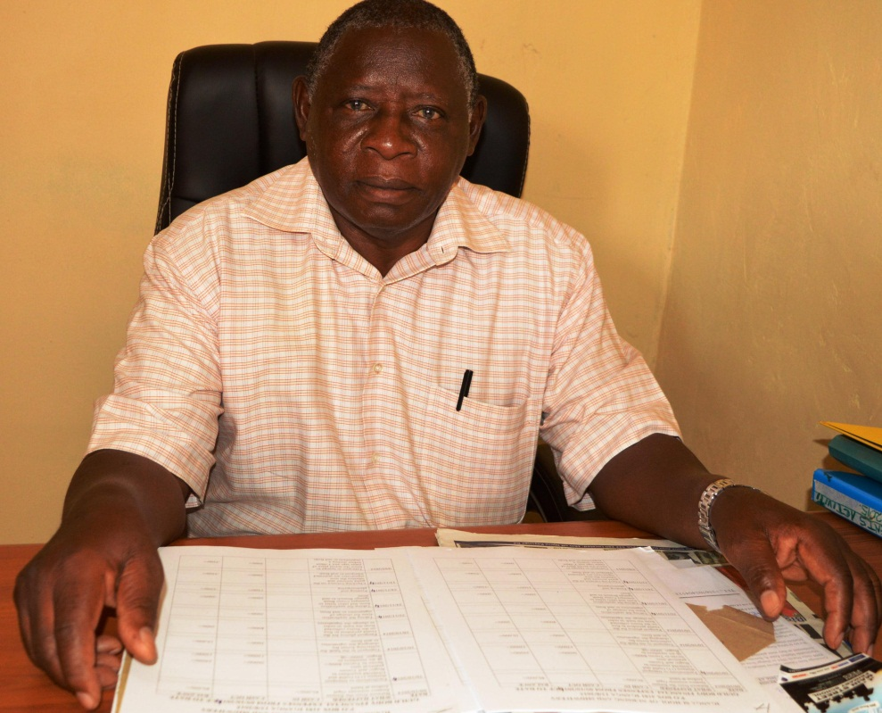


Chairman Board of Directors

Member Board of
Directors

3.2 Board of Governors:
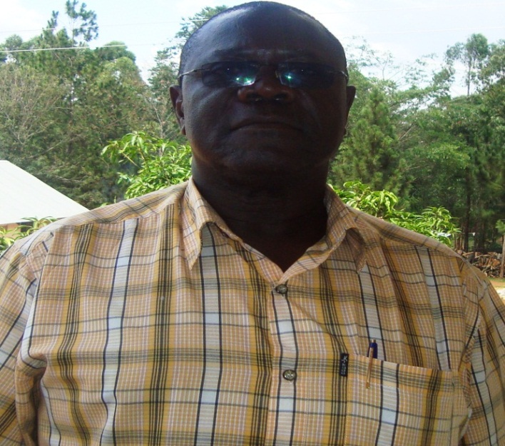
Mr. Naluwairo David Kigenyi,
Chairman Governing Council

The school has an advisory (Board of Governors) with members representing several constituents.
They include:
- Principal of ISNM who is Secretary to the council
- Staff representative of ISNM
- Representative of the parents
- 2 Student representatives (i.e. male & female)
- Representative from a Health Institution
(Busitema University)
- PNO of Iganga Hospital
- Medical Superintendent Iganga Hospital
- Religious leader
- An experienced Administrator who is Rtd CAO, Wakiso District
- Representative of the Board of Directors
The Board of Governors meets twice in each semester to advise the directors on all matters of the school with emphasis on quality education, staff and student discipline.

They are also concerned with strategic planning, reviewing reports and recommendations from their standing committee.

Ensure the smooth running of the school’s programmes both academic and non-academic by setting priorities administratively.

3.3 Management of the School
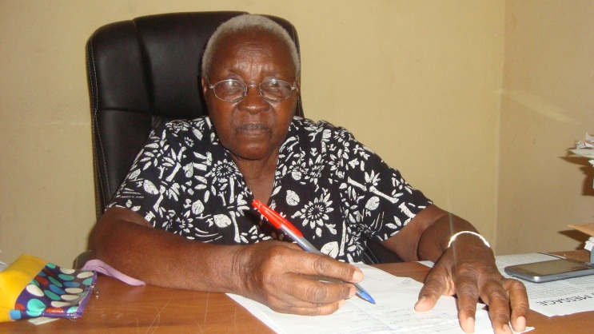
Sr. Joyce C. Zirabamuzale
Principal of the School

The Principal is responsible for the day to day running of the school assisted by the Deputy and other staff. The staff serves in various committees such as academic, disciplinary, welfare, health and sanitation. Staff meetings are held regularly.
The students have a democratically elected guild council for purposes of addressing student concerns, and liaising between the administration and the students.

- PROGRAMMES OFFERED:
Currently the school offers four (4) programs namely;-
- Certificate in Nursing
- Certificate in Midwifery
- Diploma in Nursing – Extension
- Diploma in Midwifery – Extension
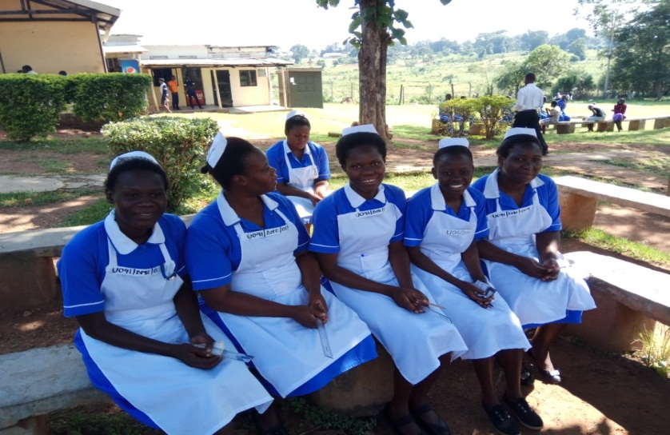
Certificate program runs for a period of 2½ years, while Diploma Extension Program runs for a period of 1½ years.

Diploma in Nursing & Midwifery – Extension

- INSTITUTIONAL ACTIVITIES CARRIED OUT:
5.1 ACADEMIC:
- Teaching and Learning activities through lectures
- Practical training in skills laboratory in school
and practicum in Hospitals/Health Centres.
- Counseling students and staff
- Assessment of practical tool books and midwifery case books
- Setting and marking tests, exams and case studies.
- Conducting both internal and external academic seminars
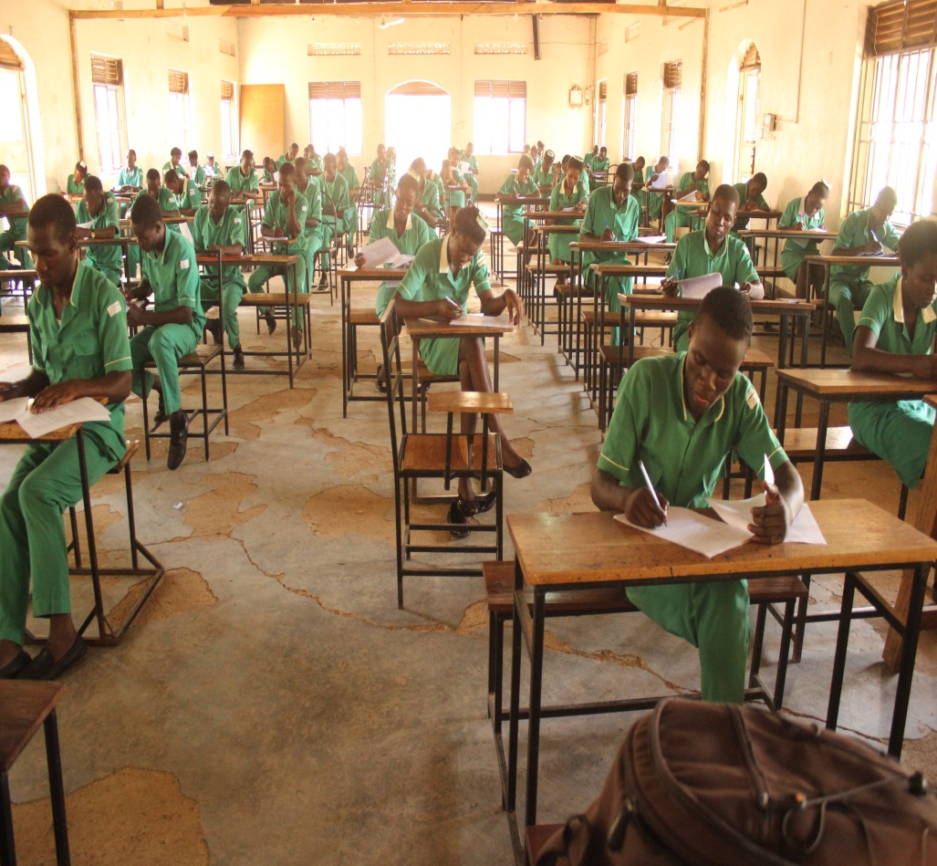
Certificate Students in an Examination

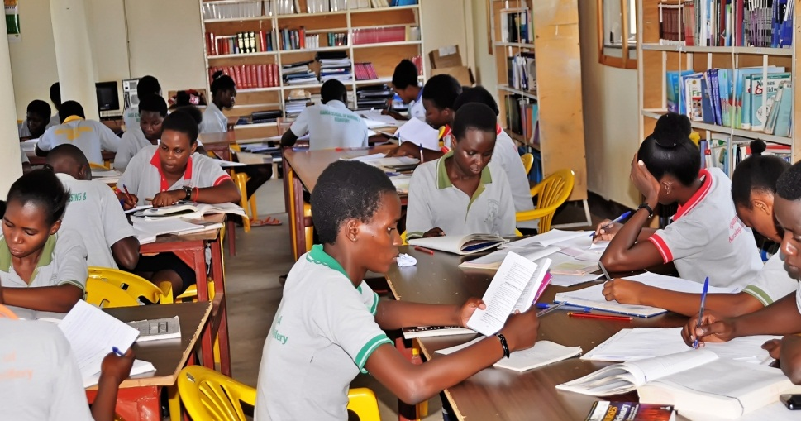
Revision session in the School Library

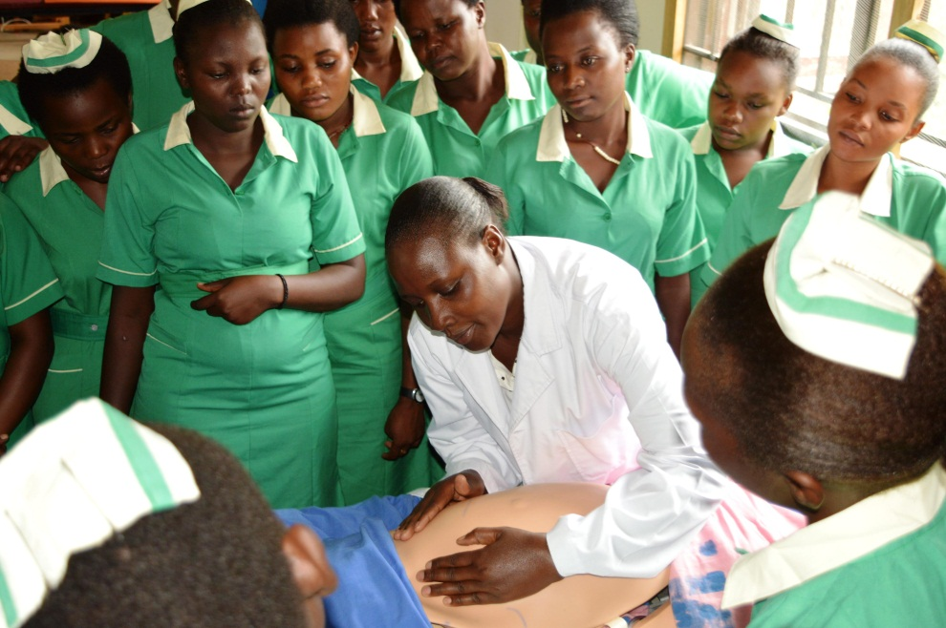
Practical training in skills laboratory

    - Practicum sites
Iganga school of Nursing and Midwifery entered into a Memorandum of Understanding (MOU) with Iganga, Bugiri, Busolwe, Tororo, Masafu and Mbale Regional Referral hospitals for the purpose of giving our students hands on practical experience. Clinical mentors at the respective hospitals assist the students on a daily basis while our tutors conduct support supervision on a weekly basis. By the time of completion of the course, the students have had an opportunity to rotate in all the hospitals. During each semester at least 8 (Eight) weeks are spent at the practicum sites while the rest of the time is for block study, skills laboratory training, tests and examinations.
At the end of each placement, the respective Principal Nursing Officers compile a report about the student’s performance and discipline and corrective action is taken where necessary.

Table 1: Practicum Sites
Name of Hospital | Ownership | Distance from school | Bed Capacity
Iganga | Government | 3km | 200
Bugiri | Government | 30km | 200
Tororo | Government | 50km | 200
Busolwe | Government | 40km | 200
Masafu | Government | 40km | 200
Mbale Regional | Government | 80km | 300
Kayunga | Government | 80km | 200

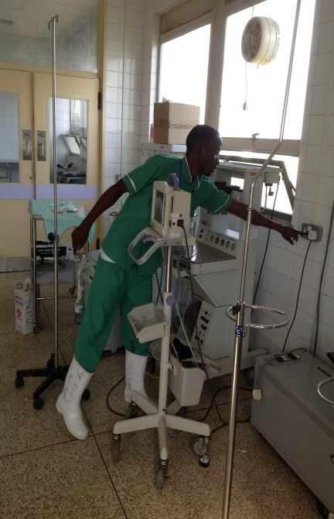
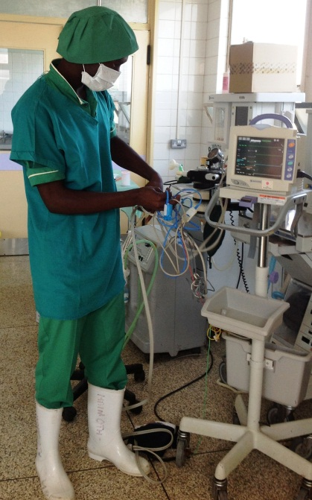
Students at practicum sites

  - Co-curricular activities
The school is involved in extra-curricular activities such as;-
- Football
- Netball
- Volley ball
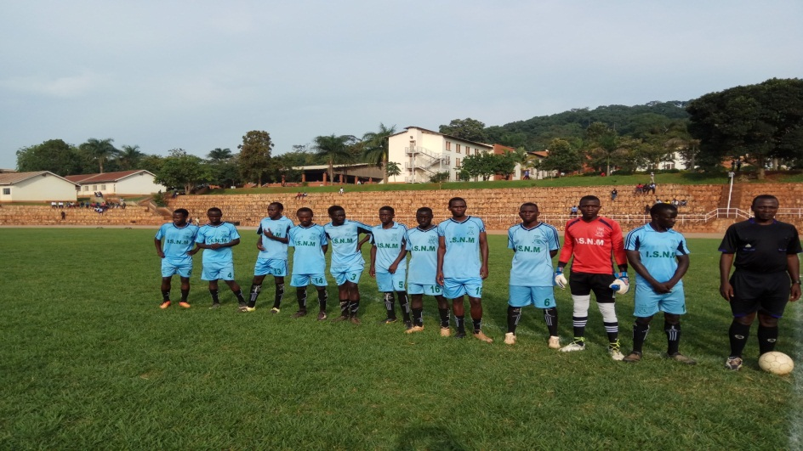

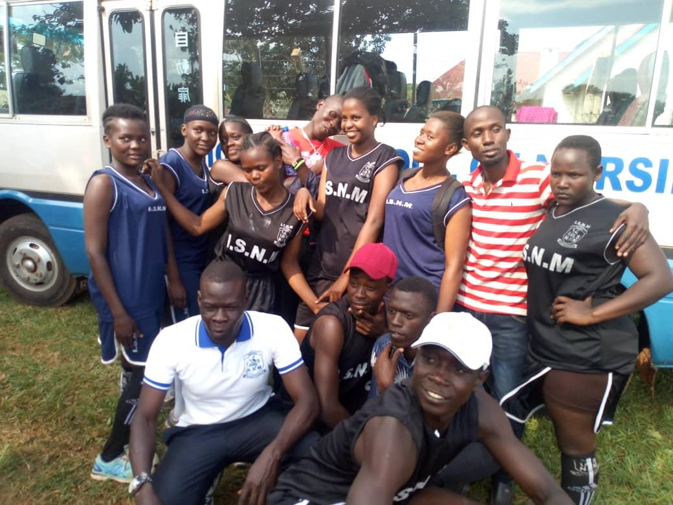
Football Club of the school at a friendly match with Uganda Christian University
- Indoor games such as:- chess, draft, scrabble etc
- Music, Dance and Drama
- Cultural Associations such as: - Basoga Nseete, Westerners Association, Nkobazambogo etc.
- Religious Associations
- Communal activities like participating in cleaning Iganga Town, charitable work like visiting the needy in prisons, hospitals etc.


6.0 INFRASTRUCTURE
The school has made remarkable infrastructural development in the past one year. There is a multi-purpose hall that can accommodate 300 students and is used to conduct internal and external exams as well as students recreational and entertainment.
The school has a complete kitchen and food store, in a permanent structure, which is connected to the main hall, where students sit for their meals.
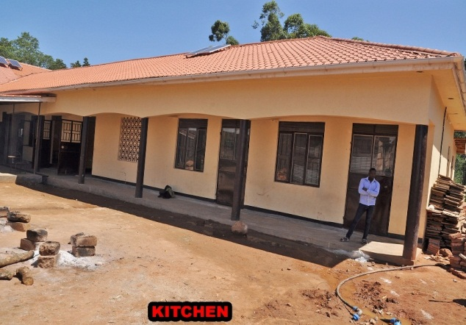

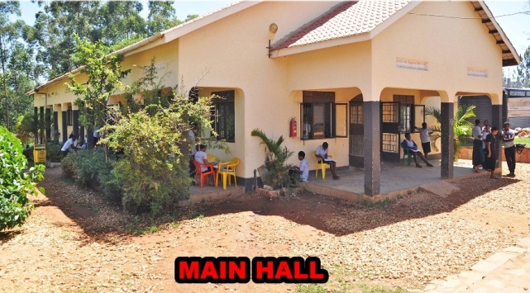

DINNING HALL/ MAIN HALL
The school has 6 (six) complete and permanent classrooms. Each classroom accommodates 60 (sixty) well seated students.
The school has a computer laboratory with 60 (sixty) functional computers. There are two Computer Instructors who assist students with both theoretical and practical computer knowledge.
The school has full time internet services that help students in research work.

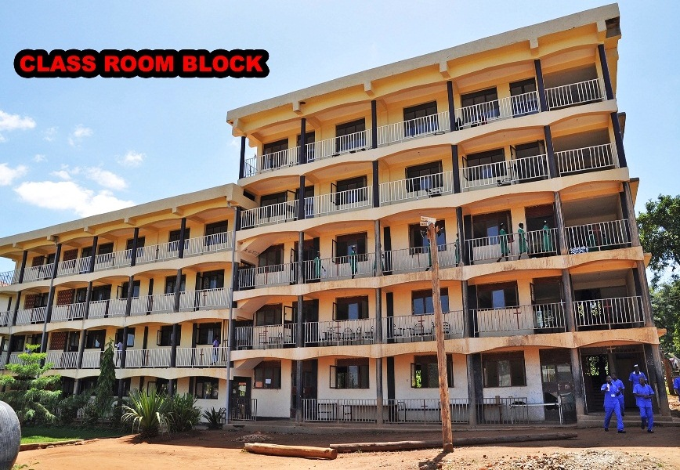
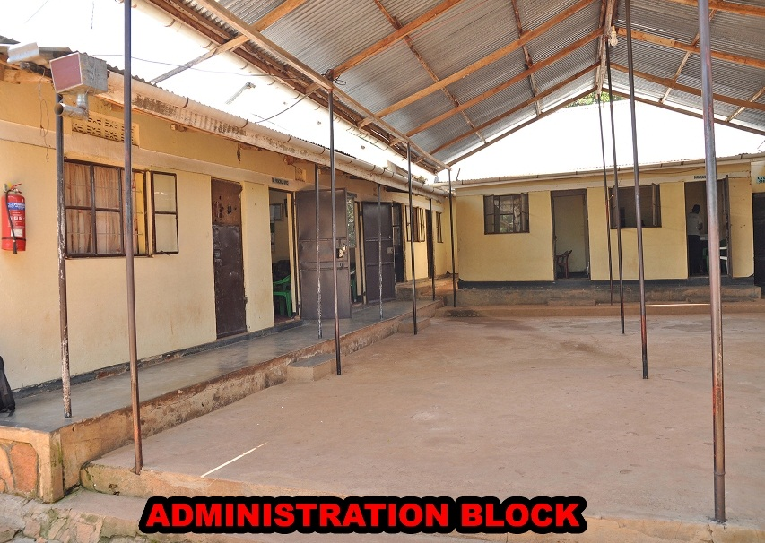
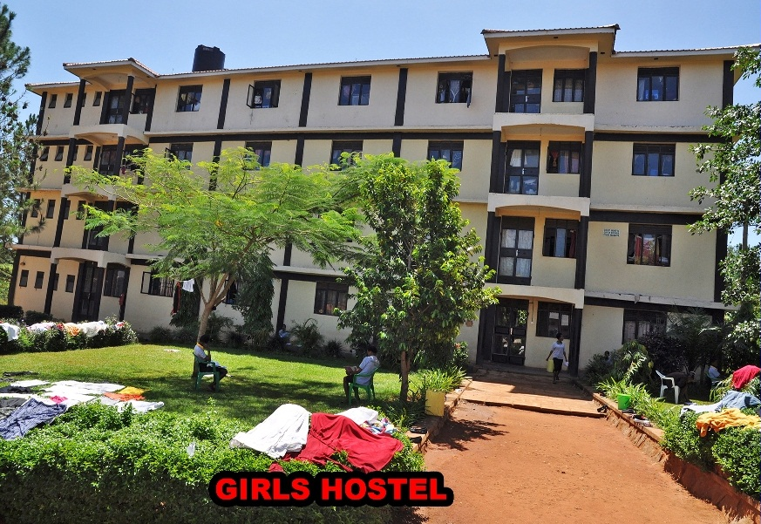
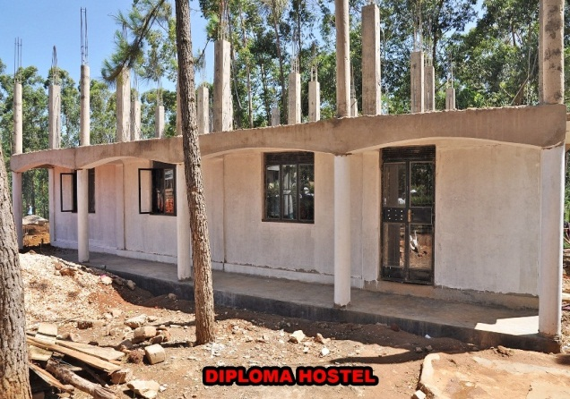

7.0 UTILITIES
The school has adequate water supplies from 3 (three) boreholes and harvested rainwater.
There are two (2) crest tanks (each has capacity of 10,000 litres) for harvesting rain water. At the same time, the school is also connected to National Water.
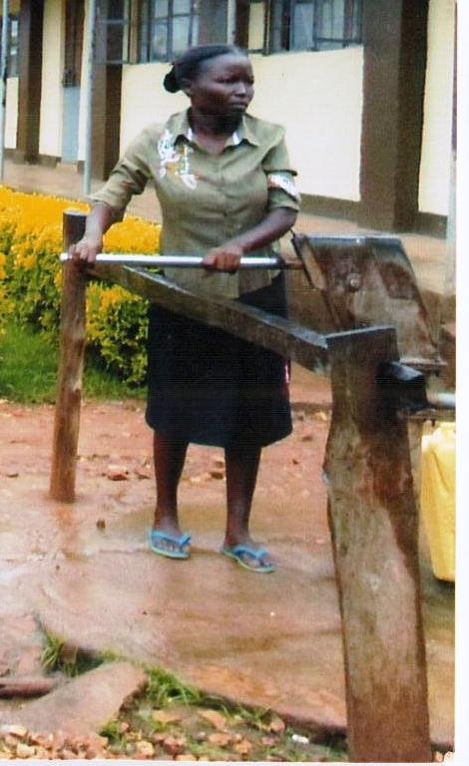
The school has several sources of power i.e. hydro-electric, solar and a standby generator in the case of load shedding. As a result, we are assured of constant power supply.

8.0 TRANSPORT
The school has two coasters buses that are used to transport the students to and from the practicum sites and other school functions held outside the school. The school also has a lorry used for ferrying firewood, food items and at times construction materials.
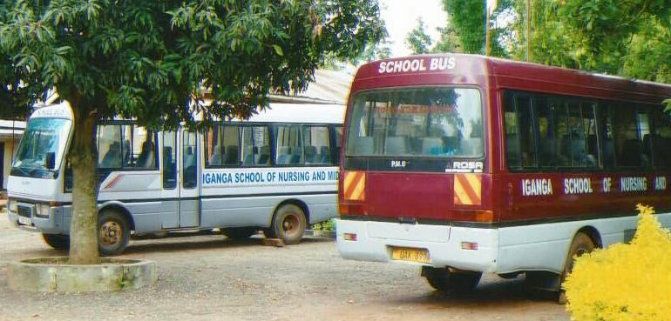
School Coasters
9.0 SECURITY
The school is surrounded with a perimeter fence of chain link. There are 5 (five) security guards who operate day and night to ensure utmost security. We organize regular meetings with the police to equip the students and staff with appropriate security prevention and mitigation measures.
Fire extinguishers are available in case of a fire outbreak. Most importantly, we have a cordial working relationship with the surroundings community.
10.0 ACHIEVEMENTS, CHALLENGES AND FUTURE PLANS
10.1 Achievements:
The school has registered the following achievements:
- Completion of a multi-purpose hall and first phase of a new storeyed girls’ hostel
- Acquisition of another Costa bust to help in transportation of students and staff to and from practicum sites.
- Separated and equipped the skills laboratories for Midwifery and Nursing sections.
- Performed very well in the past state final examinations. We have registered 00% pass rate in midwifery in all our past state exams and over 85% in nursing.
- Increased students’ population; from the original 13 students in 2009 to the current 315. The female are 231 and males 84. Of the female 117 are midwives.
- Sponsoring of four (4) staff members at the Health Tutors’ College – Mulage for Medical Education as a way of staff capacity building.
- The school has drawn a structural plan to guide future developments.
- The school has acquired generators and solar panels to address the load shedding problems
- The school acquired over 12 acres of a registered / leased land (freehold) for future development.
10.2 CHALLENGES:
In spite of the above achievements, the school faces the following challenges;
- Inadequate funding as the school currently depends on tuitions fees collected from the students
- Construction of an administration block
- Construction of a basic hospital site

10.3 FUTURE PLANS:
10.3.1 Short Term
- Mobilize more resources from within and without
- Improve the working conditions of our teaching and non-teaching staff
- Construct an administration block, classroom block, boys’ hostel.
- Procure more reference books for the library
- Continue supporting our clinical instructors to enroll for the Tutors’ Training.
10.3.2 Long Term
- Put up a fully registered Computer Laboratory within the school. This will enable students to get certificates in computer work to enrich their curriculum vitae.
- Improve institutional capacity, through setting up of departments like Human Resource, Planning, Administration, Accounts and Finance.
- Twinning with other schools
- Construct a hospital for the community and student’s practicum.
- Appeal the government to support the school through delegated funds.
- Appeal to Ministry of Education and Sports (MOES) and Ministry of Health (MOH) to identify donors to support the school.
Conclusion
Iganga School of Nursing and Midwifery is committed to fulfilling its objectives as evidenced by its achievements within the three years of its exercise. This has been attained as a result of the support and guidance from several stakeholders for whom we are grateful. We intend to build on these achievements to take the school to the next level. We call upon the government and all the key stakeholders to continue supporting and guiding the school in this endeavour.

